# Reusing the NIS ITA Science Library

This document is designed to help take the NIS ITA Science Library and apply it to other data about publications and authors, e.g. for a different research programme. The document will continue to be updated as enhancements to the underlying model and the user interface are made.

Current version: 1.1

Date: 25th April 2016

Authors: Dave Braines (IBM UK)

The latest version of this document can be found on the ITA Science Library website, here -> <http://nis-ita.org/ScienceLibrary/>

## General information

* Please use **Google Chrome** for the Science Library and the ce-store engineering panel if possible. Other browsers also work but we have only tested these specific instructions in Google Chrome.
* When setting up the ce-store we recommend that you use Tomcat 7 as the web application server and suggest that you stick with the default name “Tomcat v7.0 Server at localhost” when setting it up.
* These instructions assume that you are running on localhost:8080 for both the Science Library and the ce-store engineering panel.
* The following URLs are mentioned throughout the document:
  + Engineering panel - <http://localhost:8080/ce-store/ui/>
  + Science Library - <http://localhost:3000/>
* The live version of the NIS ITA Science Library can be found here -> <http://nis-ita.org>

## Basic ce-store installation

Follow the instructions for installing and testing the open source ce-store -> <https://github.com/ce-store/ce-store/blob/master/README.md>

This includes the installation of the Eclipse development environment and a suitable web application server such as Apache Tomcat.

Verify that the ce-store is working correctly (by using the example “Medicine” model as per the github instructions) and that the “engineering panel” (default user interface) is running at <http://localhost:8080/ce-store/ui/>

Notes:

1. The ce-store uses a number of common 3rd party JS libraries (DOJO, OpenLayers, Proj4js, Google maps and D3). By default these are loaded from existing online locations. If you wish to develop and test whilst disconnected from the network you will need to download local copies of these and edit **ce-store/WebContent/ui/index.html** to point to your local copies instead.

## Installation of Science Library data and user interface

Download the following zip files from the ITA Science Library website, here -> <http://nis-ita.org/ScienceLibrary/>

1. **SL_generator.xlsm** – this is the master spreadsheet which contains all of the Science Library data and from which you can generate the required Controlled English files.
2. **SL_static.zip** – this contains example “static” content such as an example paper, the preview image for it and some profile pictures for people.
3. **SL_data.zip** – this contains the minimal Controlled English (CE) to define a single paper, authors, organisations, events and other supporting data. This is used to prove that the Science Library environment is working correctly.
4. **ScienceLibrary**.zip – This is the NodeJS codebase for the ScienceLibrary.

Unzip each of the three zip files into your Eclipse “workspace” folder and then import these projects into your Eclipse environment. The SL_static and SL_data projects should then be added to your Tomcat server (using the popup menu for that server, selecting “Add/Remove Projects” and move these three projects from the left side to the right side to add them).

The **ScienceLibrary.zip** file contains a NodeJS version of the ScienceLibrary User Interface and needs to be run inside NodeJS. You will also need to install ‘bower’ and ‘grunt’.

You can use the command ‘bower install’ to pull the latest dependencies and ‘grunt serve’ to run the ScienceLibrary user interface as a NodeJS application. This will run by default on port 3000, meaning that you can open your browser on <http://localhost:3000> to access the Science Library UI (Note that the Science Library will be empty unless the later stages of this document are followed).

It is also possible to generate a version of the UI for running within Tomcat and these instructions will be updated with details of how to do that in a future version.

To make it as easy as possible to load the Science Library data, edit the file named **ce-store/WebContent/ui/js/ui/panes/pane-currentprojects.js**

This file determines what links are shown in the “Current Projects” pane in the ce-store engineering panel.

Replace line 47:

{ url: 'ce-store/ce/medicine/cmd/med_load.cecmd', name: 'Medicine' }

with:

{ url: 'ce-store/ce/medicine/cmd/med_load.cecmd', name: 'Medicine' },

{ url: 'SL_data/ce/cmd/load_live.cecmd', name: 'Science Library' },

{ url: 'SL_data/ce/cmd/load_cached.cecmd', name: 'Science Library (cached)' },

Now refresh the ce-store and the “current projects” pane should look like this:

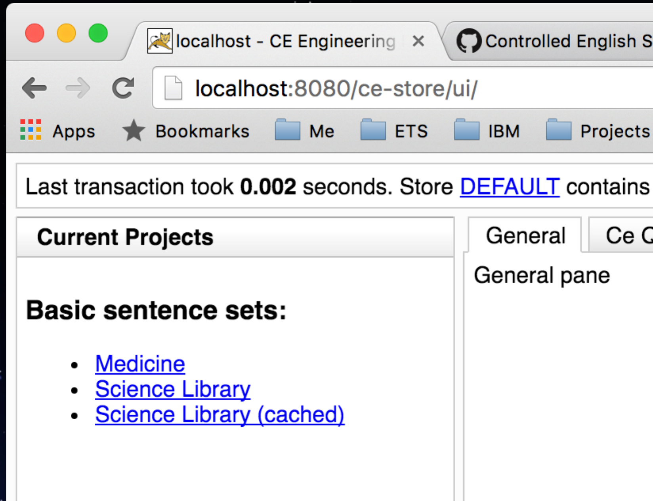

Clicking on the “Science Library” links will simply execute the relevant CE command file within the “SL_data” project and therefore load that CE knowledge base into the ce-store.

## Load and test the Science Library

In the ce-store engineering panel click on the “Science Library (cached)” link to load in all of the sample Science Library data. You will be asked to confirm the action, and when you do so you should see a message box like this after a very short pause:

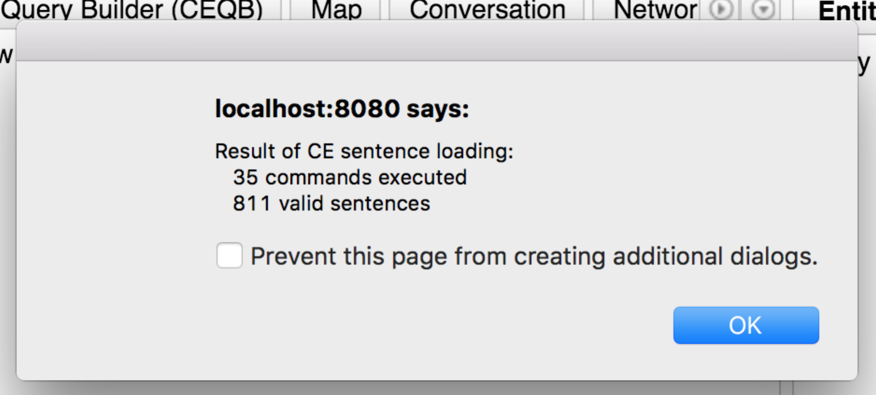

You can now use the ce-store engineering panel to explore the underlying CE data should you wish to. Please refer to the ce-store tutorials on github for an explanation of how to do this.

The main user interface for the Science Library can now be accessed, here -> <http://localhost:3000/>

The home page should look like this:

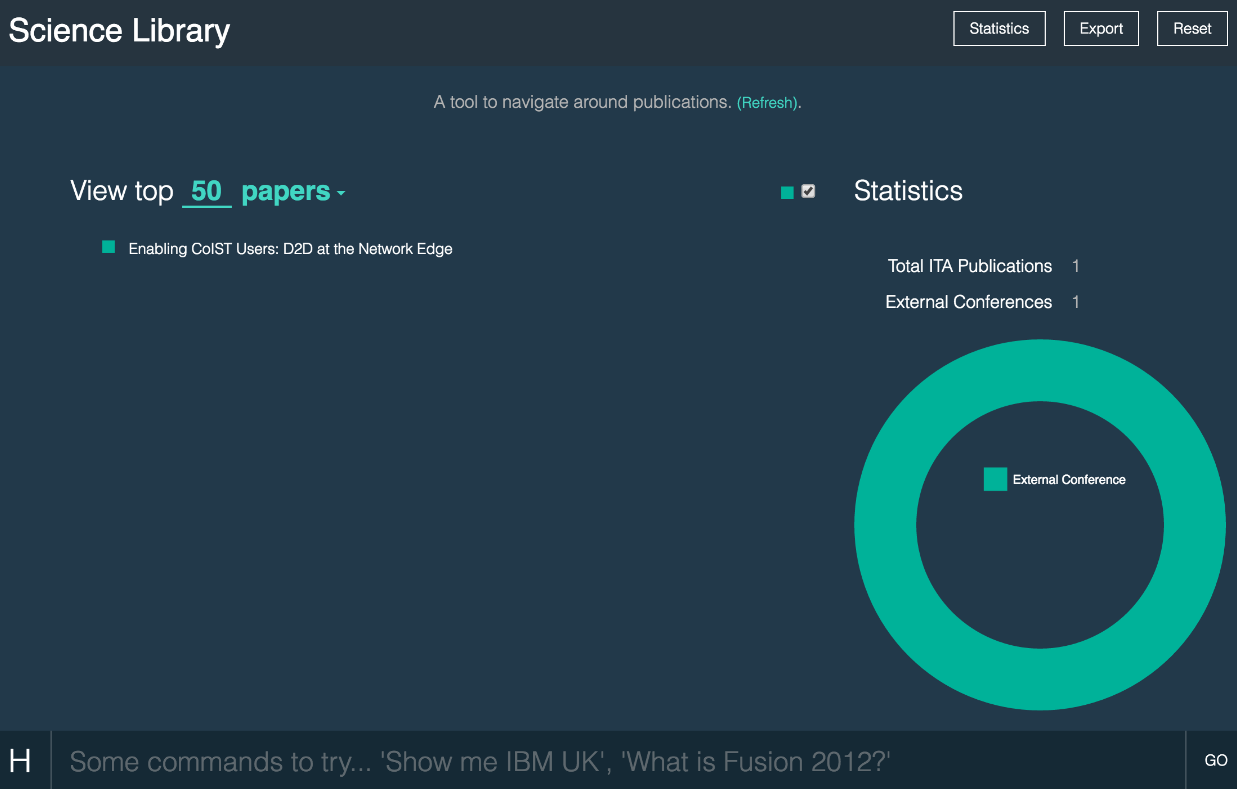

In the sample data set there is only a single paper, 3 authors, 3 organisations and one event defined.

Don’t forget about using TomCat 8 for the rewrite valve and placing rewrite.config into WEB-INF.

Need to add instructions about using the spreadsheet to generate the CE.